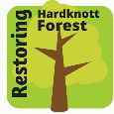
Restoring Hardknott Forest Phase 1 Habitat Survey Summary

Summer 2020

Tasmin Fletcher (Project Assistant)

Background and rationale
Hardknott Forest is a 635 hectare site managed by the University of Leeds in partnership with Forestry England. Since the 1930s the site has been primarily used as a softwood plantation, however in recent years, areas of clear fell are regenerating naturally, rather than being replanted for timber. Regenerated non-native tree species are being selectively removed to allow native species to establish across the site.
Consequently, there is significant variation in habitat type across the site and periods of change as areas are converted from softwood plantation to a native habitat mosaic. A habitat survey was deemed useful to gather information on the distribution of habitats across the site and to monitor how these change with time.

Methodology
A Phase 1 Habitat Survey (P1HS) was considered suitable for the site, due to the ability to survey relatively rapidly, whilst retaining sufficient accuracy for management applications.
The survey was conducted following the guidelines found in the JNCC Handbook for Phase 1 habitat survey. A 1:10,000 Ordnance Survey MasterMap was used as a base map, using a minimum mappable area of 0.1 ha. Habitats were marked on field maps using the alphanumeric hierarchical codes given in the JNCC handbook and target notes taken on the main plant or tree species found in each area.
The JNCC habitat codes for categories B-J were used as given in the handbook, however for category A (Woodland and scrub), the classification was adapted to include two additional levels to provide greater detail for use in future management of the site. The additional Level 4 and Level 5 categories were estimated by eye during surveying on site. The adapted classification for category A is given in Table 1. Percentage canopy cover, given in Level 4, refers to the area of open ground not covered by foliage, rather than the distance between trunk stems.
Level 1* |  | Level 2 |  | Level 3 |  | Level 4 |  | Level 5
1 | Woodland | 1 | Broadleaf  (90-100% broadleaf) | 1 | Semi-natural (including self-regenerated) | 1 | Scattered (<30% tree cover) | 1 | Up to 1m height
2 | Scrub | 2 | Coniferous  (0-10% broadleaf) | 2 | Plantation | 2 | Medium (30-60% tree cover) | 2 | 1-3m height
 |  | 3 | Mixed  (10-50% broadleaf) |  |  | 3 | Dense (>60% tree cover) | 3 | 3-5m height
 |  | 4 | Mixed (50-90% broadleaf) |  |  |  |  | 4 | >5m height
Table 1: Adapted classification for woodland and scrub habitats
*The original Phase 1 includes two further categories in Level 1: (3) Parkland and scattered trees and (4) Recently-felled woodland. (3) is now redundant due to the insertion of Level 4, which accounts for density. (4) is also potentially redundant as the handbook states only areas whose future land-use is unclear are to be classified as this. At Hardknott, future felled blocks will either be classed as woodland with small saplings, or as grassland/bog/heath etc.
In some sections, such as areas of clear fell with recent regrowth, there could be a degree of ambiguity over habitat classification. Therefore, if the tree cover was less than 30%, a classification of woodland was preferentially assigned, with a secondary classification given to the background vegetation (e.g. grassland, bracken or heath).
The survey was carried out on all land owned by Forestry England at Hardknott, including areas currently leased for grazing around Castle How, Hinning House and the Birks. The land around Grassguards was also included, although privately owned. The proximity of these habitats to the main Hardknott Forest site means they may aid interpretation of surveys of other wildlife, such as breeding birds, and give context to the site as a whole.

Results
A total of 64 different habitat types were identified across the site. The most common habitat was semi-improved acid grassland, which accounted for 105 ha or 17% of the total site. Figure 1 shows the areas of different habitat types across the site. For ease of interpretation, woodland habitats have been grouped according to their Level 2 classification (see Table 1). Collectively, woodland habitats account for 400 ha, which is 63% of the total site. A map of simplified habitat categories is shown in Figure 2.
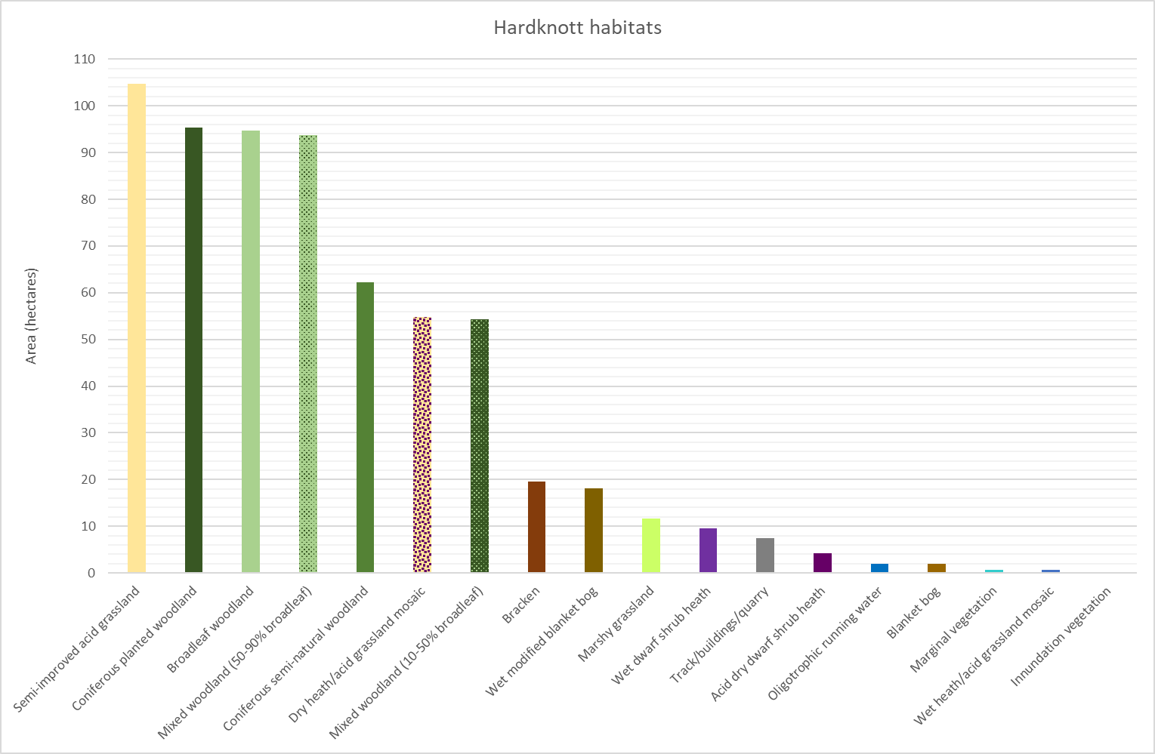
Figure 1: Area of different habitats surveyed during the 2020 P1HS
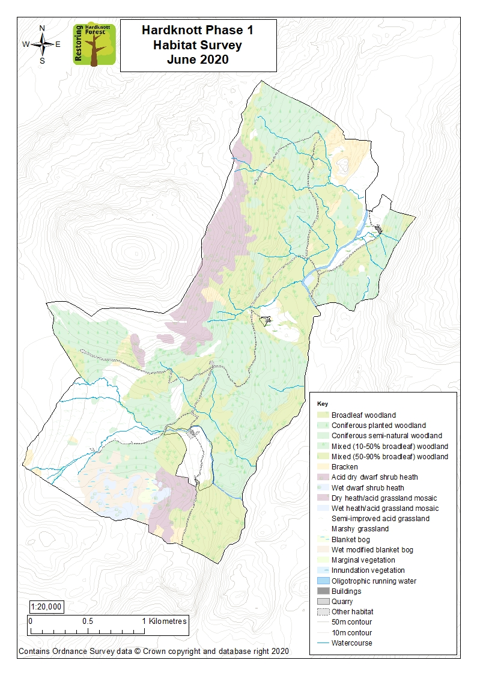
Figure 2: Map of simplified habitat categories at Hardknott Forest

Woodland habitats
Of the area covered by woodland, the majority is classified as broadleaf, as shown in Figure 3. Collectively, 158 ha are covered with coniferous woodland, however only 95 ha of this is plantation, with the remaining 62 ha being regenerated (semi-natural) coniferous trees.
Excluding areas of coniferous plantation, 29% of total woodland is classified as majority coniferous (either semi-natural coniferous or mixed woodland (10-50% broadleaf)), compared to 47% as majority broadleaf (broadleaf or mixed woodland (50-90% broadleaf)).
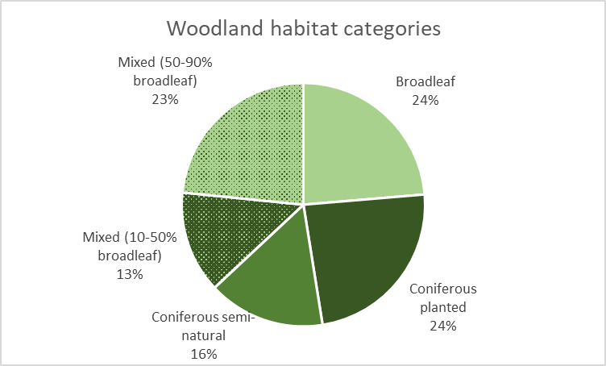
Figure 3: Proportions of different woodland habitat categories out of total area of woodland

Canopy height
Figure 4 shows the canopy height within different woodland habitats. This highlights that roughly half of all areas of woodland over 5m high are coniferous plantation, with the remaining area split evenly between majority broadleaf and majority conifer. All coniferous plantation on site is over 5m high and therefore reaching maturity.
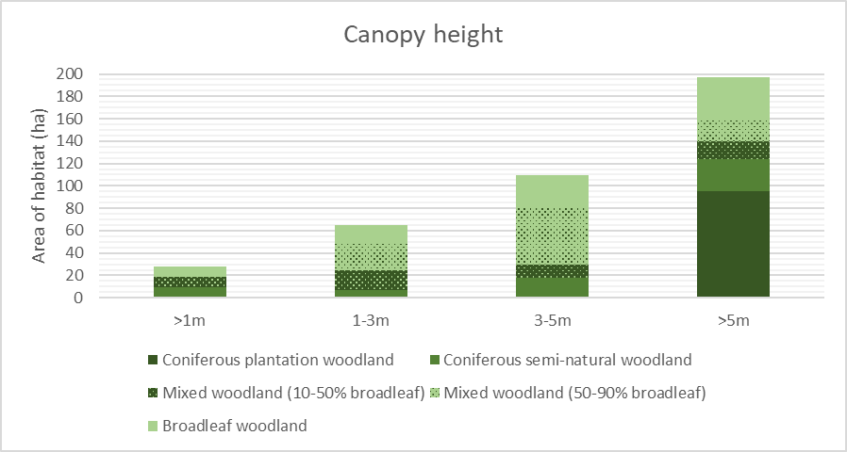
Figure 4: Canopy height of different woodland habitats
Of the 175 ha with canopy heights between 1m and 5m, nearly 70% are classified as majority broadleaf, showing that much of the area of broadleaf has yet to reach maturity. Only 28 ha are classed as woodland >1m tall, of which around two thirds are majority coniferous.

Percentage tree cover
Figure 5 shows the percentage tree cover of areas classified as woodland habitat. Three fifths of total woodland habitat have tree cover of greater than 60%.
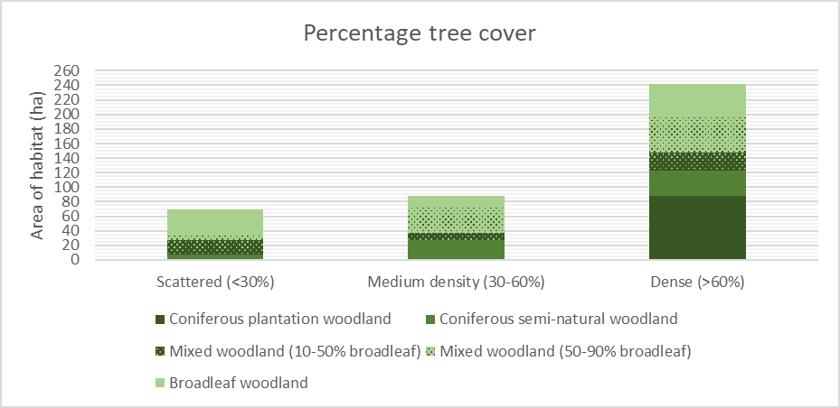
Figure 5: Percentage tree cover of different woodland habitats
As shown in Figure 6, the areas of greatest canopy height generally have a greater percentage canopy cover, as bigger trees have more foliage and so cover more ground. Areas with smaller trees generally have a lower percentage tree cover.
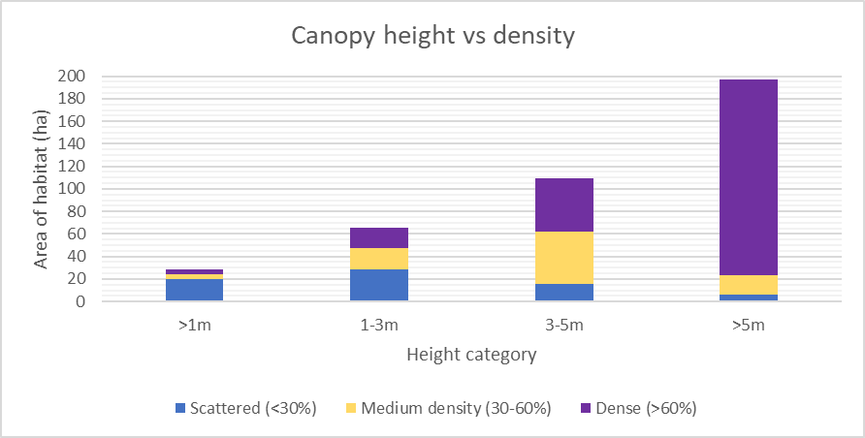
Figure 6: Canopy height and percentage tree cover of different woodland habitats

Grassland and heath habitats
186 ha (29%) of the site are classed as a either a grassland or heath habitat. This includes semi-improved acid grassland, marshy grassland, dry dwarf shrub heath, wet dwarf shrub heath and both wet and dry heath/acid grassland mosaics. The JNCC handbook states that the mosaic categories are included for ease of mapping and recommends that relative proportions of each habitat are target noted. Due to site conditions and terrain, estimating proportional habitat coverage of the mosaic areas was deemed too difficult, therefore a 50/50 split is assumed (as recommended in the handbook). This gives an overall estimation of semi-improved acid grassland coverage of 132 ha with 32 ha of dry heath and 10 ha of wet heath.
Both dry and wet heath are generally found at higher elevations on the site, particularly on rocky outcrops where coniferous plantations were not established.
Most rock or crag outcrops are included within these categories as the handbook states that only rock over 2m high and sloping at more than 60˚ should be classed as inland cliff, with vegetated cliffs being mapped using the relevant vegetation code.

Other habitats
Other notable habitats on site include bracken (both continuous and scattered), blanket bog and aquatic habitats. Bracken accounts for 3% (20 ha) of the site, with the largest swathe found around Castle How. Collectively, blanket bog and modified bog cover also cover 20 ha and are found to the south-west of the site near Wallabarrow Heald. The majority of the peat bog here has been disturbed by ploughing/drainage and planting, however the small section furthest from the access track remains relatively unaltered.
The predominant aquatic habitat is oligotrophic running water, found in both the River Duddon and smaller tributaries such as Grassguards Gill and Castlehow Beck. Marginal vegetation and inundation vegetation account for 0.7 and 0.2 ha respectively, and are found along the edge of the River Duddon north of the bridge at the main car park.

Evaluation and conclusions
The P1HS provides an overview of the habitats found on a site experiencing relatively rapid land use change. Just under two thirds of the site is woodland, with nearly half of this categorised as majority broadleaf habitat. However, most of these areas of broadleaf have estimated canopy heights of less than 5m, showing that the trees are still establishing. Canopy cover varies across the wooded habitats but is generally lower in areas where trees have a lower canopy height. 95 hectares (around 15%) of the site is covered by same-age stands of coniferous plantation, which are reaching maturity.
As the land use on site changes, a diverse mosaic of habitats is developing, with significant areas of heath, bog, bracken and grassland, particularly in the upper parts of the site.
The 2020 P1HS will be a useful tool for interpreting surveys of wildlife distribution and impact, as well as aiding management of the site and providing a benchmark for monitoring future habitat change.

